po box 2093, Santa Barbara, Calif. 93120
e-mail: info@householdink.com (www.householdink.com/joe-woodard)

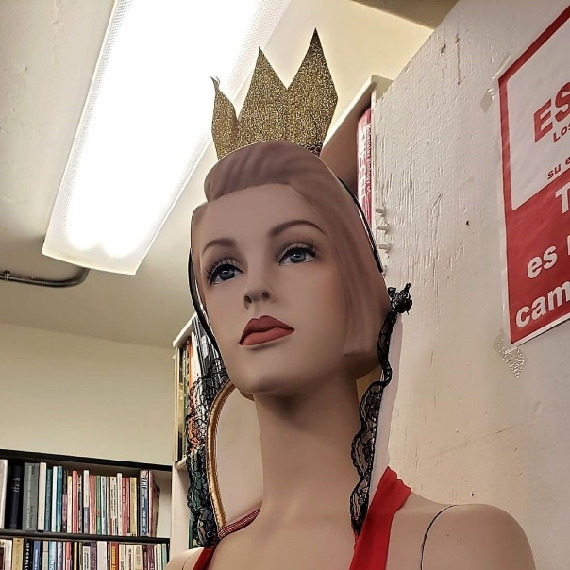
Headless
Household,
“The Numbers Game”

(Household Ink Records, 2023, HI-158)

Due to pandemical and other disruptive factors, the new music outfit Headless Household (b. 1983) has gone semi-dormant in the past few years. And yet the intrepid archivist team at Household Ink Records have rolled up sleeves and gotten busy during this “downtime,” digging up gems--and gems in the roughage--from the in-house vaults, going back a few decades. Plans are now underway to release archival findings of interest and/or titillation, both in terms of singles and longer form collections of would-be treasures.
Unveiling number one: the previously-unreleased song “The Numbers Game,” recorded live at Santa Barbara's Center Stage Theater on December 4, 1995, and featuring the mighty, and mighty lyrical Nate Birkey on vocal and trumpet. Also on the track are Arlene Dunlap (in absentee sampled form, as real-time numerologist), and the usual Headless crew: pianist Dick Dunlap, bassist Chris Symer, drummer Tom lackner and guitarist/songwriter Joe Woodard.
Birkey, who has played many times on Household shows and recordings and has released 10 of his own albums on the Household Ink label, would be relocating to New York City soon after this concert.
As the song says, “that's life, that's math/that's how the numbers fall.”

Headless Household albumography: Headless Household (1987; vinyl), Inside/Outside USA (1993), ITEMS (1995), Free Associations (1999), mockhausen (2000), post-Polka (2003), Blur Joan (2005), and Basemento (2010), Balladismo (2015).
Links to “The Numbers Game:”

www.householdink.com/headless
www.natebirkey.com
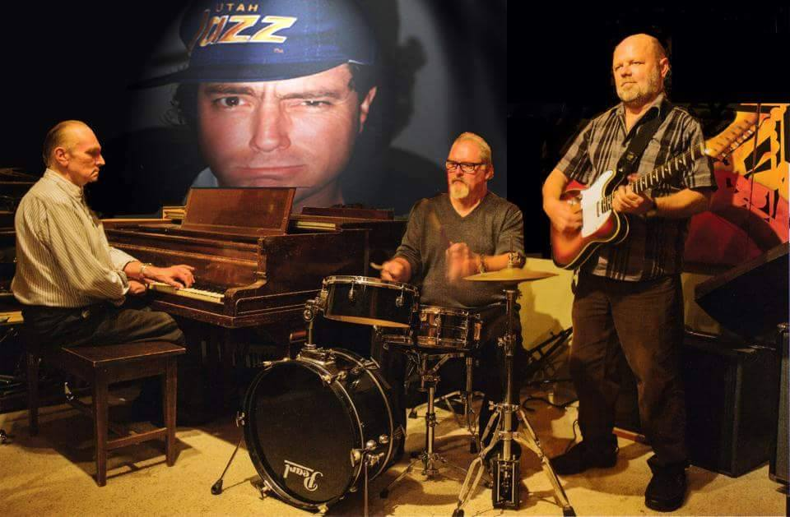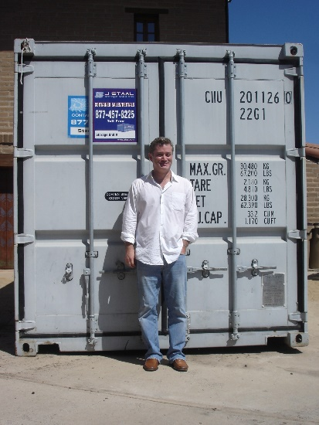
Headless Household (photo: MacDuff Everton, with insert) Nate Birkey
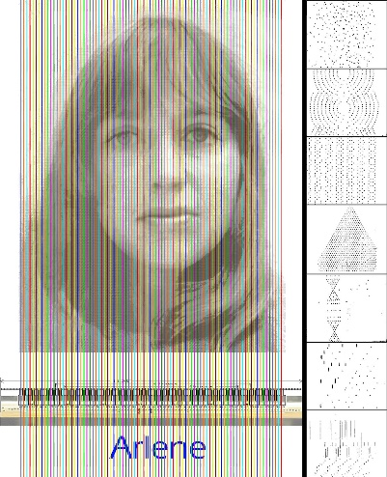
Arlene Dunlap (treatment: Dick Dunlap)

Headless Household Press bites:

(re: Balladismo)

"There’s just no encapsulating the entirety of this quartet’s breadth of expressions. Cross-genre interconnecting lines of sonic languages somehow are molded into a deliriously fun mix of old & new jazz, bluegrass, folk, avant-garde and classical minimalism. ... a good barometer for the creative fearlessness at work here."
--Dave Sumner, "Bird is the Worm" blog link

"The cover of Headless Household’s Balladismo shows the barely discernible figure of a woman dreamily reclining beneath a foreground of stormy ocean waves. It’s a fitting image for an album that shifts and ripples gently between various low-key avant stylings — takes on jazz, lounge, soft rock — while maintaining a dreamy blue mood throughout. ... enduring band of regional free spirits... It’s an album to sink into."
--Richie DeMaria, Santa Barbara Independent link

”There’s just no encapsulating the entirety of this quartet’s breadth of expressions. Cross-genre interconnecting lines of sonic languages somehow are molded into a deliriously fun mix of old & new jazz, bluegrass, folk, avant-garde and classical minimalism. At its core, they’re a quartet of keyboardist Dick Dunlap, drummer Tom Lackner, bassist Chris Symer and guitarist Joe Woodard, but the inclusion of a diverse line-up that brings together pedal steel, saxophone, electronics, vocals, violin and trumpet is a good barometer for the creative fearlessness at work here.”
--Dave Sumner, "Bird is the Worm" blog link
(re: Basemento)
http://www.relix.com/reviews/cds/2010/07/22/gabor-szabo-headless-household-omar-souleyman-and-more-ear-crystals
“Santa Barbara’s Headless Household celebrates 25 years of criminal neglect with a wonderful double album, Basemento (Household Ink). Come for “This, That…,” guitarist Joe Woodard’s song-oriented SoCal strip-mall blend of jazzy bossa nova and Bakersfield country laments (i.e., “Jobim Meets Jim Beam”). But stay for “…The Other,” a disk’s worth of some of the smartest and friendliest psychedelic jazz you’ll ever snuggle up to. Guest saxophonist Dave Binney applies the hot sauce liberally to these nine smart, incisive sonic meditations encompassing everything from British progressives like Henry Cow, gnarly New York downtown jazz, Weather Report’s international feel and the heady cosmic geologies of countless Grateful Dead space excursions.”
--Richard Gehr, Relix, July, 2010
“No, Headless Household is not an Industrial band. They sound like Miles Davis playing with the Kronos Quartet conducted by Sun Ra with occasional vocals by George Jones and backup singers from A Man and a Woman. Wonderful and wonderfully bizarre. If and when Twin Peaks gets another stab at prime time TV, Headless Household would be the perfect band to play at the lodge.”
--Nick Dedina, Rhapsody.com
Re: Basemento CD release concert at the Lobero Theatre:
“Overall the vibe was great and the music eclectic enough to satisfy any head, household member or not.”
–Charles Donelan, Santa Barbara Independent

“Santa Barbara, California, a hot bed for creative music? Well, that may be an overstatement, but like many towns throughout the world, there is creative music to be found seemingly everywhere. Hailing from Santa Barbara is Headless Household, an eclectic ensemble…Soundwise, it is an eclectic and surprisingly alluring program that covers a variety of genres that, while certainly experimental, remains accessible. The group’s interest in the fusion of electric and acoustic touches is seen from the outset… Overall, a quirky--in a good wy--outing from a group that is certainly charting its own course.
--Jay Collins, Cadence, Oct. 2006
“…solid musicianship and an admirable willingness to toss in whatever strikes their fancy.” --Aaron Steinberg, Jazz Times, July/August, 2006
“Long-running Santa Barbara eclecto-jazz weirdoes Headless Household have simmered all their exotic flavors into a very palatable goulash called Blur Joan (Household Ink). Joe Woodard,Dick Dunlap and Tom Lackner really orchestrated this one, and with the help of brilliant friends (Dave Binney, Jim Connolly, Julie Christensen et al.), swing and waltz and reggae and sound effects unite — natural, warm and full of protein.”
--Greg Burk, Los Angeles Weekly, May 10, 2006

