
P.O. Box 2093, Santa Barbara, CA 93120
e-mail: info@householdink.com (www.householdink.com)

post-Polka
(a subsidiary of Headless Household)
does “Növemberfest” @ Muddy Waters, Saturday, November 26
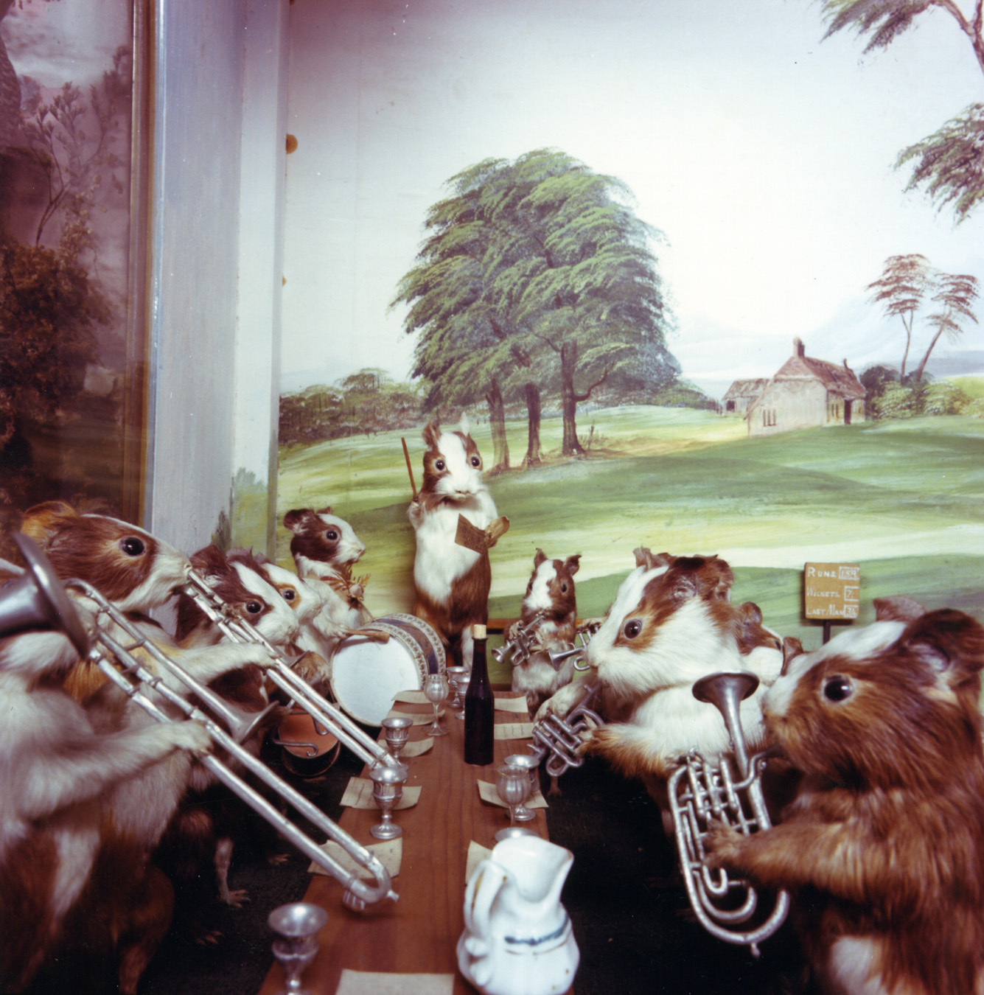
For immediate release:

What: , post-Polka (a subsidiary of Headless Household), second annual “Növemberfest,” with AnnaAbbey/JimConnolly/ColterFrazier opening
Where: Muddy Waters, 508 E. Haley St., Santa Barbara
When: Saturday, November 26, 8:30 p.m.
Tickets: $5 (beer tariff not included)
Contact: (805) 966-9328, www.myspace.com/muddycafesb, info@householdink.com

Santa Barbara’s premiere avant-polka band, post-Polka (a subsidiary of Headless Household) is back in Muddy Waters action, for the second annual “Növemberfest.” The band kicks up the polka at Muddy Waters on Friday, November 26. Opening for p-P is an exciting, as-yet-unnamed new odd-art-pop band, presently identified as AnnaAbbey/JimConnolly/ColterFrazier.
In 2003, Headless Household released the conceptual polka album post-Polka. Some loved it. Others didn’t. Others are still snoozing in the jury box. After a couple of strictly-polka gigs, a resolve was made to create a spinoff band, hereby dubbed post-Polka.
At the moment, the members of post-Polka are: Julie “the polka queen” Christensen, bassist Jim Connolly, faux accordionist Dick Dunlap, drum man Tom Lackner, guitarman Joe Woodard, saxist/clarinetist Tom Buckner, violinist/vocalist Sally Barr, multi-instrumental wizard/nice guys Bill Flores and… (?) This is not your father’s polka, unless your father likes Jimmy Sturr, Brave Combo, Stravinsky, Zappa, John Zorn, Nino Rota, and modulating waltzes.
Recorded at the old Riviera Studios by Wayne Sabbak and at the Tompound by Tom Lackner, post-Polka was the sixth album by Headless Household and its 20th anniversary celebration project. It has gone on to be one of the band’s “hottest” sellers, especially in the digital realm. With luck and gumption, another post-Polka album is in the works… Go figure. Come polka.

Press for post-Polka

“Almost every song here benefits from unusual arrangement or instrumentation choices, veering closer to a Soul Coughing fever dream than a classical polka album. But while this isn't your grandparents' polka, it isn't Weird Al's pop-culture mockery, either. Headless Household are men who understand the need to balance irreverence with reverence, who realize that the clarinet can be ominous, who know that clowns are scary…a willingness to expand your horizons and a broad sense of humor will help immensely. Still, despite the relative taboo of polka itself among the "forget where you came from" generation, I'd recommend Post Polka to anyone willing to wrap their head around it. After all, when's the last time you heard an album that refused to let you down?”
--Justin Kownacki, Splendid e-zine, www.splendidezine.com

“The first thing to understand about the Household’s music is that when they announce a genre—say, polka for example—that hardly means they will stick to anything much resembling a traditional polka, or even that one of their polkas will sound much like another…. What unites these disparate approaches is a commitment to the sound and values of free improvisation… Everything that gets thrown into this musical blender seems to belong there…Here’s to many more years of this unique Santa Barbara tradition.”
--Charles Donelan, Santa Barbara Independent, re: the 2006 xmas concert

“One of the last unexplored realms of Americana is the rich and colorful tapestry of European-American polka music. Charlie Mingus was to have said, `White man, study your polkas.’ Here Headless Household playfully has opened the songbook…”
--Greg Drust, Milwaukee-based Polka DJ/scholar, from his post-Polka liner notes

On the worldwide interweb:

www.myspace.com/postpolkatheband

www.householdink.com/post-Polka.htm

www.facebook.com/post-Polka

For further information, photos, music, et al, please visit www.householdink.com.
e-mail: info@householdink.com

