
P.O. Box 2093, Santa Barbara, CA 93120
e-mail: info@householdink.com (www.householdink.com)

post-Polka (a subsidiary of Headless Household), presides over an “alt-Oktoberfest” at Mercury Lounge, Thursday, October 29
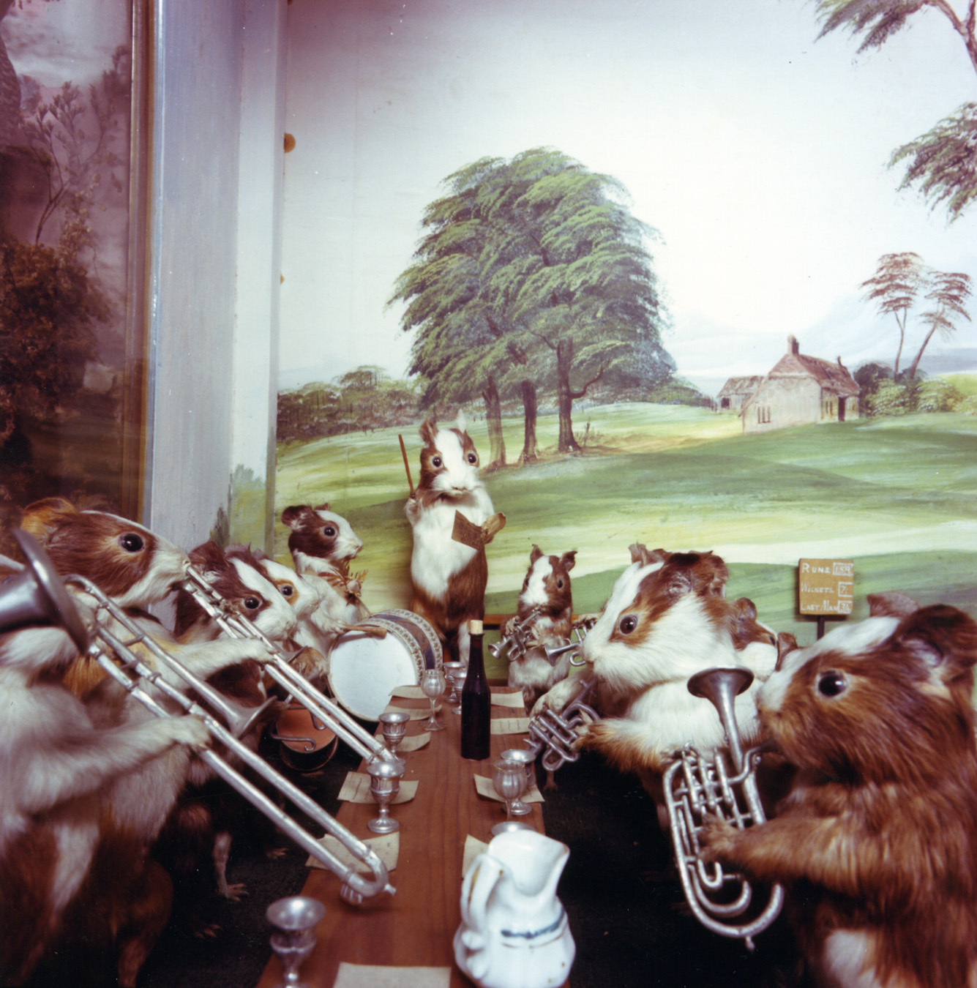
For immediate release:

What: post-Polka (a subsidiary of Headless Household), in an “alt-Oktoberfest!” show
Where: Mercury Lounge, 5871 Hollister Ave., Goleta
When: Thursday, October, 29, 9 p.m.
Tickets: free! (beer tariff not included)
Contact: 967-0907, www.myspace.com/mercurylounge,
info@householdink.com

With the arrival of post-Polka, a new band is born (well, reborn), helping to fill the void of polka music in Santa Barbara. In 2003, the hopelessly confused and eclectic band Headless Household released the conceptual polka album post-Polka. Some loved it. Others didn’t. Others are still snoozing in the jury box.
After a cool (and tasty!) gig at an Oktoberfest gig at the SB Museum of Natural History, a resolve was made to create a spinoff band, hereby dubbed post-Polka, to deal strictly with the polka portion of the by-now fairly massive, 26-years-deep Headless Household songbook. And what better way to kick things off than with an “alt-Oktoberfest” show at the beloved Mercury Lounge in fun-loving Old Town Goleta?
At the moment, the members of post-Polka are: Julie “the polka queen” Christensen, bassist Jim Connolly, faux accordionist Dick Dunlap, drum man Tom Lackner, guitarman Joe Woodard, saxist/clarinetist Tom Buckner, violinist/vocalist Sally Barr, multi-instrumental wizard/nice guys Bill Flores and Kenny Edwards and… (?) This is not your father’s polka, unless your father likes Jimmy Sturr, Brave Combo, Stravinsky, Zappa, John Zorn, Nino Rota, and modulating waltzes.
Recorded at the old Riviera Studios by Wayne Sabbak and at the Tompound by Tom Lackner, post-Polka was the sixth album by Headless Household and its 20th anniversary celebration project. It has gone on to be one of the band’s “hottest” sellers, especially in the digital realm. Go figure. Come polka.

Press for post-Polka
“Almost every song here benefits from unusual arrangement or instrumentation choices, veering closer to a Soul Coughing fever dream than a classical polka album. But while this isn't your grandparents' polka, it isn't Weird Al's pop-culture mockery, either. Headless Household are men who understand the need to balance irreverence with reverence, who realize that the clarinet can be ominous, who know that clowns are scary…a willingness to expand your horizons and a broad sense of humor will help immensely. Still, despite the relative taboo of polka itself among the "forget where you came from" generation, I'd recommend Post Polka to anyone willing to wrap their head around it. After all, when's the last time you heard an album that refused to let you down?” --Justin Kownacki, Splendid e-zine, www.splendidezine.com
“The first thing to understand about the Household’s music is that when they announce a genre—say, polka for example—that hardly means they will stick to anything much resembling a traditional polka, or even that one of their polkas will sound much like another…. What unites these disparate approaches is a commitment to the sound and values of free improvisation… Everything that gets thrown into this musical blender seems to belong there…Here’s to many more years of this unique Santa Barbara tradition.”
--Charles Donelan, Santa Barbara Independent, re: the 2006 xmas concert

“One of the last unexplored realms of Americana is the rich and colorful tapestry of European-American polka music. Charlie Mingus was to have said, `White man, study your polkas.’ Here Headless Household playfully has opened the songbook…”
--Greg Drust, Milwaukee-based Polka DJ/scholar, from his post-Polka liner notes

On the worldwide interweb:

www.myspace.com/postpolkatheband

www.householdink.com/post-Polka.htm

For further information, photos, music, et al, please visit www.householdink.com.
e-mail: info@householdink.com

