
P.O. Box 2093, Santa Barbara, CA 93120
(805) 687-3963, FAX (805) 682-8305
e-mail: HouseInk@aol.com (www.householdink.com)

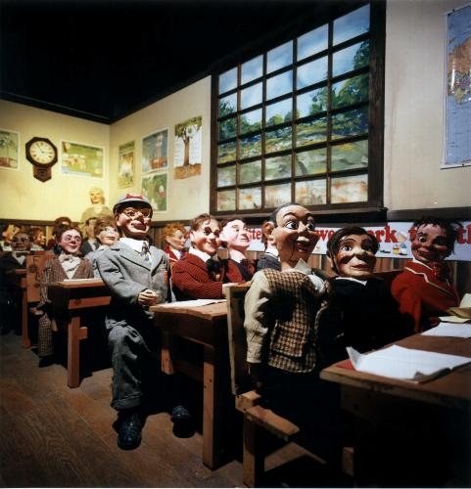
Headless Household
mockhausen

Formed in 1983, the confusingly eclectic New Music group Headless Household has just released its fifth album: mockhausen is a collection of outtakes, improvisation, and other artful noises, and is the least “commercial” one yet. From a motley range of sources, both live and studio-bound, structurally free and…well, slightly less free, a strange continuity emerges. One could even call it psycho-meditative.

The discography: Headless Household (1987), Inside/Outside USA (1993), Items (1996), and Free Associations (1999), mockhausen (2000), all released on Household Ink Records. The group: Dick Dunlap, plugged and unplugged keyboards, Tom Lackner, percussions, Chris Symer, basses, Joe Woodard, guitars and turntables. Guests kindly join in, too. On several tracks, including the great New York-based alto saxist Dave Binney contributes his more-than-two-cents worth, attitudinal trumpeter Jeff Kaiser can be heard on “Skippy Elvin,” and Ellen Turner offers her luminous pipes to the concluding ballad, “Wintry (Invention).”

PRESS CLIPPINGS (re: earlier works): “Music this wildly diverse can never be properly marketed in this age of specialization, but that doesn’t make it any less extraordinary.” **** (four stars) --Bill Milkowski, Tower Pulse magazine, Oct. 1999 “The opening three performances reveal this cooperative's challenging scope…a precision, depth, warmth and ease of feeling that can rival any other outfit in the professional mainstream. Lovely stuff.” --David Lewis, Cadence; “Like groups like Medeski, Martin and Wood, Headless Household's vision of jazz is one of expanding boundaries and eclecticism…. Wraps it up in a not-quite-round, not-quite square package labeled `jazz.’” --Noah Wane, Splendid e-zine; "Headless Household still seems to think that a mind is a terrible thing to waste." --Greg Burk, L.A. Weekly…“This Santa Barbara combo plays endearingly bizarre pop, bop, swing, and several other genres with impeccable musicianship and a sly sense of humor.”--Rafer Guzman, East Bay Express.

Press clips and playlists are greatly appreciated.

The product is available via mail-order, for a $12 (postage-paid) check or money-order sent to Household Ink, P.O. Box 2093, Santa Barbara, CA 93120, or via plastic at the humble web-home: www.householdink.com.

