
p.o. box 2093, Santa Barbara, CA 93120
e-mail: info@householdink.com (www.householdink.com)

Nate Birkey releases seventh album on Household Ink Records,
Just a Closer Walk, a Unique and Soul-felt Jazz-Flavored take on Spirituals and Gospel Material

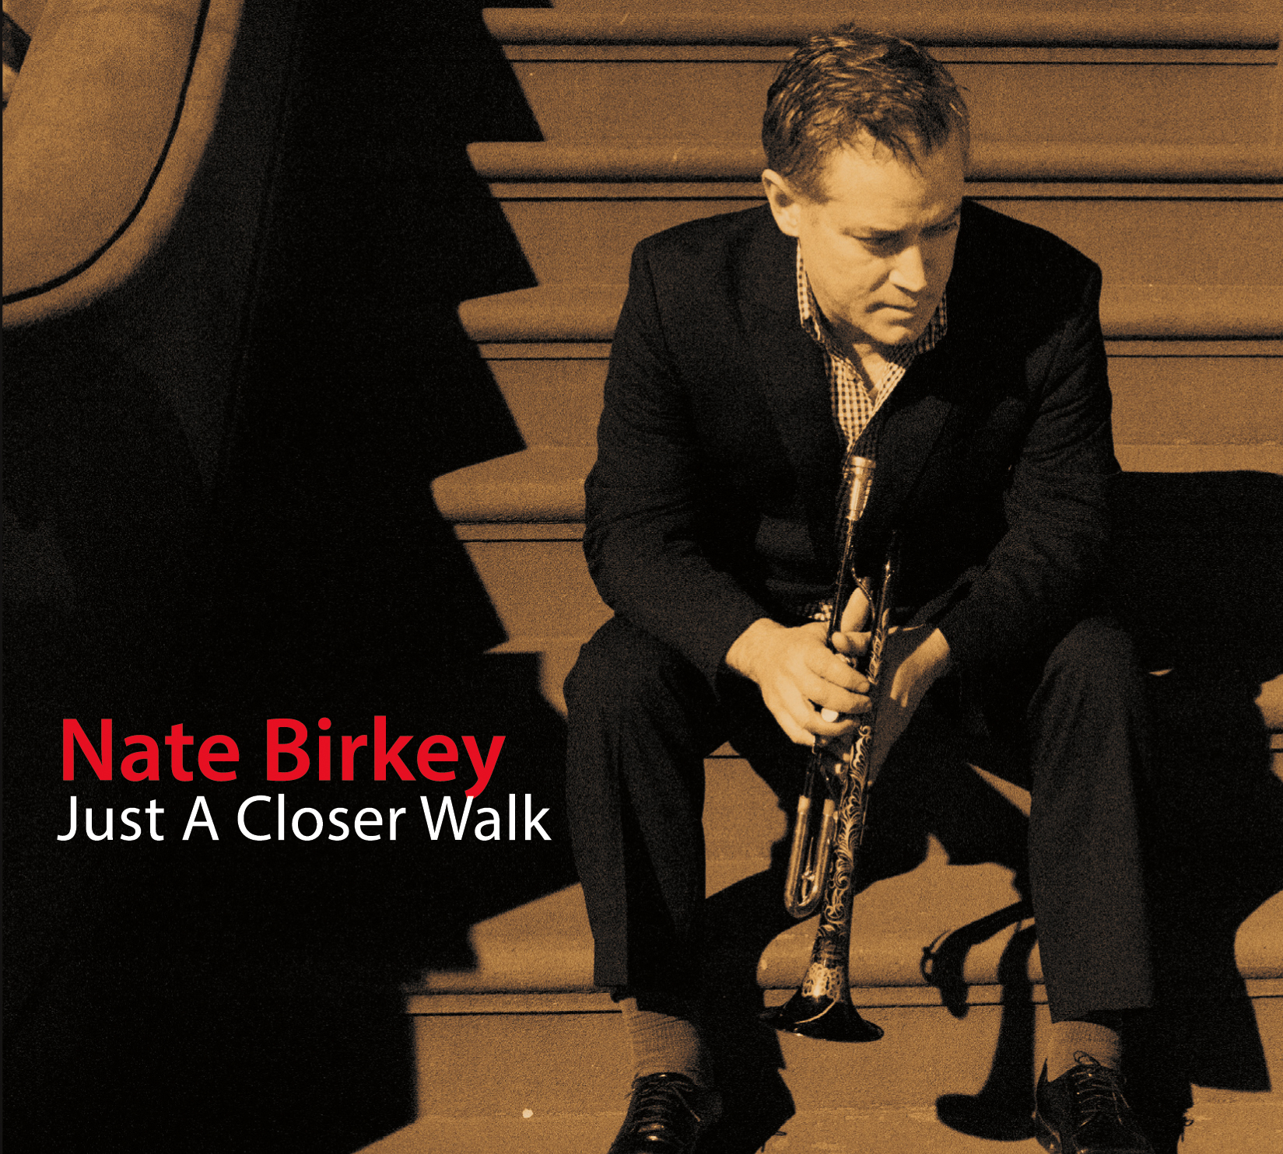
NYC-based jazz trumpeter, vocalist and bandleader Nate Birkey has built a solid reputation for creating a modernizing “mainstream” musical voice, steeped in subtle swing and expressive lyricism which has earned comparisons to Chet Baker, while making careful, tasteful detours into other rhythms and genres. He steps into some terrain both new and old by offering fresh yet traditional approaches to the realm of gospel music and spirituals on the album Just a Closer Walk with Thee, his latest and seventh album on the Household Ink label.
Recorded in Santa Barbara, where Birkey lived for several years before heading east, the inspiring all-instrumental song set features the ripe and empathetic work of his “west coast” quintet, with pianist Jamieson Trotter, tenor saxist Tom Buckner, bassist Jim Connolly and drummer Peter Buck. It’s another strong addition to a fascinating discography and musical adventure in progress for Birkey.
This isn’t the first time Birkey has followed a particular conceptual path on an album: he focused his musical attentions on earlier albums with the deceptively simple, self-descriptive titles, 2001’s Ballads and 2008’s Christmas. Alongside the pulse of personalized “straight ahead” jazz in the foundation of Birkey’s approach, his taste for New Orleans, Latin and other elements in the music can also be heard on his Household Ink debut, 1998’s Indelibly You, as well as The Mennonite (2001), The Shortest Day (2004) and Almost Home (2008).
Just a Closer Walk, similarly, stokes the long tradition of a gospel influence in jazz while adding some twists of Birkey’s own devising. Jazz classics with a gospel pedigree included the opening “Cristo Redentor,” the Duke Pearson tune made famous by trumpeter Donald Byrd on his own spin on the gospel-jazz handshake, and Count Basie’s “The Deacon.” A New Orleans-ian groove percolates on his arrangement of “What a Friend We Have in Jesus,” while a brass chorale effect lends a hushed, spiritualized glow to the 19th century hymn “O Sacred Head, Now Wounded” (one of the favorite hymns of Birkey’s mother back in his childhood home in Colorado: she is a Mennonite, incidentally).
That brief, sanctuary-suitable track segues gracefully into the title hymn, “Just a Closer Walk with Thee,” given a natural jazz cred and improvisatory flex by the quintet. The album closes with a nod to the great African-American spirituals repertoire, “Soon Ah Will Be Done,” by which time we’re true believers in the project’s musical mission, regardless of one’s link to the religious affiliations involved.
Just a Closer Walk is another strong addition to a fascinating discography and musical adventure in progress for Birkey.

"Nate Birkey, he of mysterious charisma, subtle gossamer trumpet lines and understated voice, hunches over the microphone and leans into his phrases, shutting out the world."
Josef Woodard, Los Angeles Times

Links: www.natebirkey.com
www.householdink.com/natebirkey.htm

Downloadable photos @ www.householdink.com/picturehole.htm
For further info, photos, mp3s, CDs, press clips, etcetera, please e-mail info@householdink.com www.householdink.com

Nate Birkey photos: http://www.natebirkey.com/gallery/

http://www.householdink.com/natebirkeyphotos/htm

