
p.o. box 2093, Santa Barbara, CA 93120
(805) 687-3963, FAX (805) 682-8305
e-mail: info@householdink.com (www.householdink.com)

Headless Household follows up Lobero Theatre concert with “Spring Sing ’10,” at SOhO on Wednesday, June 23

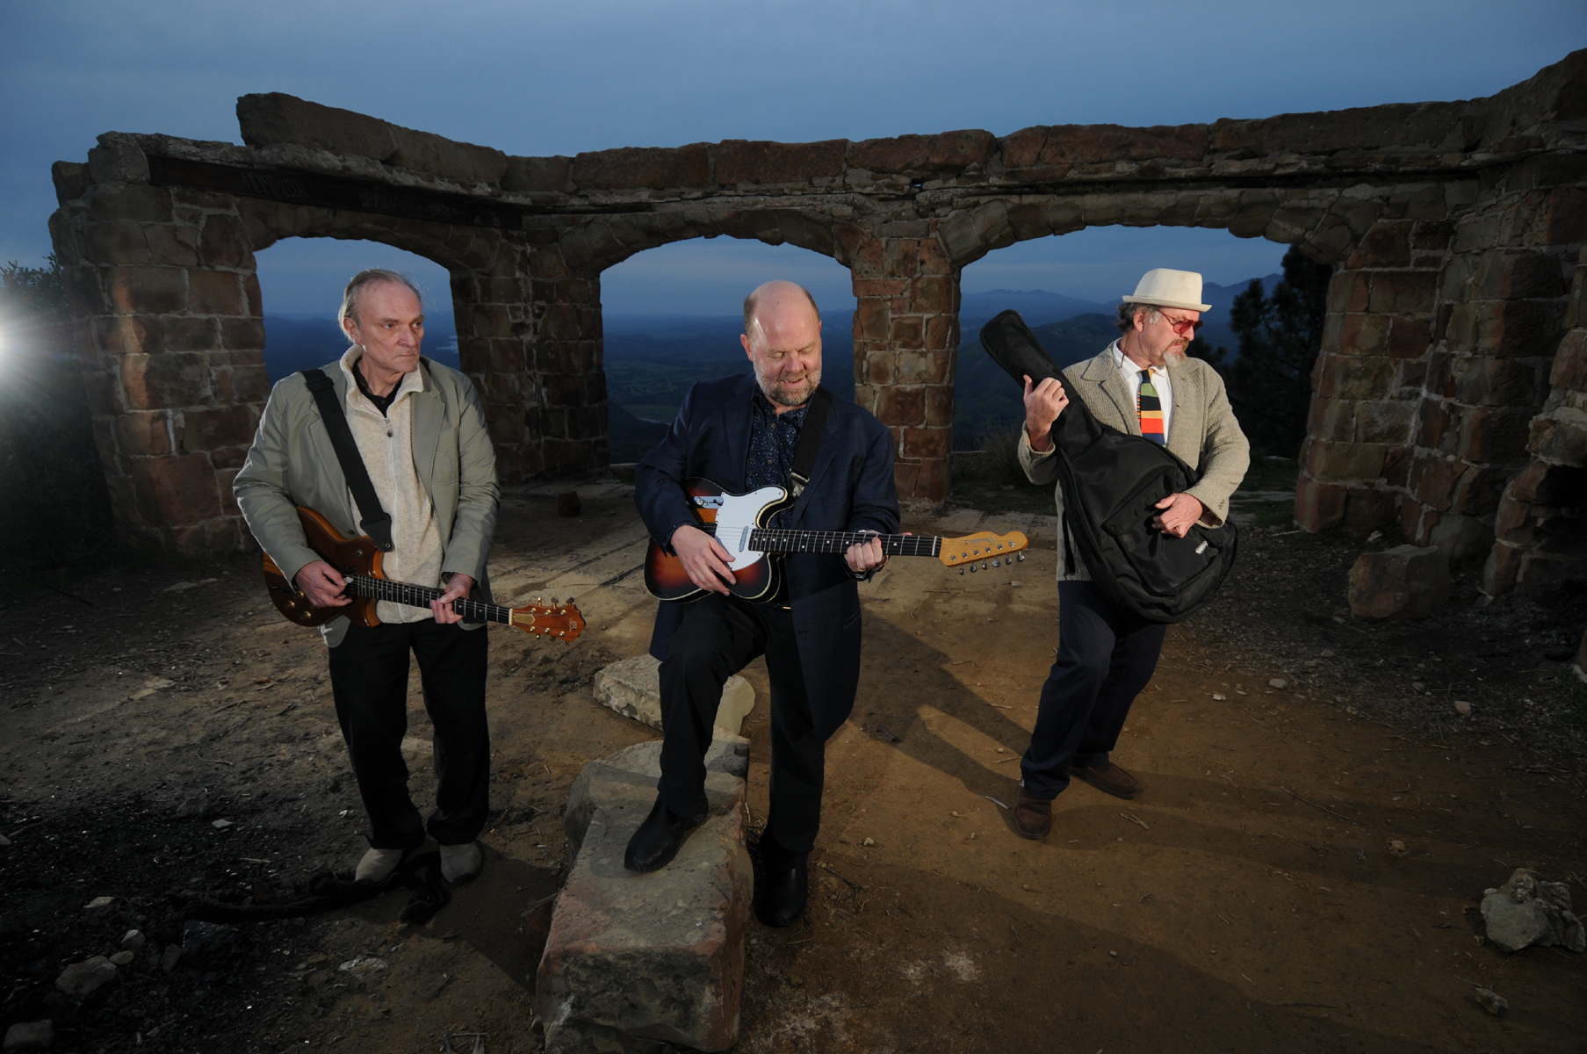
What: Headless Household, "Spring Sing '10"
When: Wednesday, June 23, 8 p.m.
Where: SOhO, 1221 State St. Santa Barbara CA
Cost: $10
Information: (805)-962-7776, www.sohosb.com
Who: Dick Dunlap, Tom Lackner, Joe Woodard, Julie Christensen, Tom Buckner, Sally Barr, Kenny Edwards, and ? (photo: Paul Wellman)
Fresh off of a March concert at the Lobero Theatre to celebrate the release of its 25th anniversary CD, the double-disc Basemento, Headless Household returns to another favorite venue, SOhO, for its "Spring Sing '10," on Wednesday, June 23. Santa Barbara's demise-proof and favorite “etcetera-ist” band mixes up elements of jazz, free improvisation, avant-Americana, Europeana, rock, soul, Braziliana.
Basemento—the latest findings from the Household “basement”(actual and figurative)--is another hard-to-pinpoint musical journey, running through the jungles of genres, a torch song or two, sweet vocals and electro-acoustic ambient constructions. Etcetera. It seemed only proper to make it a two-disc album, one—“This, That…”-- leaning more “inside” and the other—“The Other—“ “outside.”
In progress for five years, Basemento was interrupted for nearly a year after the Tea Fire threw the process off course. Previous albums to date, all on the in-house Household Ink Records label: Headless Household (1987), Inside/Outside USA (1993), ITEMS (1995), Free Associations (1999), mockhausen (2000), post-Polka (2003), and Blur Joan (2005). More to come, apparently.

Links:

www.householdink.com/news.htm
www.myspace.com/headlesshousehold
www.householdink.com/headless.htm

photos:
www.householdink.com/hhphotos.htm

Press bites
“…solid musicianship and an admirable willingness to toss in whatever strikes their fancy.”
--Aaron Steinberg, Jazz Times
-“Music this wildly diverse can never be properly marketed in this age of specialization, but that doesn’t make it any less extraordinary.” --Bill Milkowski, Tower Pulse magazine
“Headless Household still seems to think that a mind is a terrible thing to waste..”
--Greg Burk, L.A. Weekly

Re: Lobero Theatre concert:

“Overall the vibe was great and the music eclectic enough to satisfy any head, household member or not.”
--Charles Donelan, Santa Barbara Independent
_____________________________________________________________________________________
e: info@householdink.com
w: www.householdink.com

