
p.o. box 2093, Santa Barbara, CA 93120
(805) 687-3963, FAX (805) 682-8305
e-mail: info@householdink.com (www.householdink.com)

Headless Household pays tribute to friend and ally Kenny Edwards with “Remembering Kenny,” featuring the band, and guest singer-songwriters,
Monday, March 21, at SOhO,
benefiting Sarah House

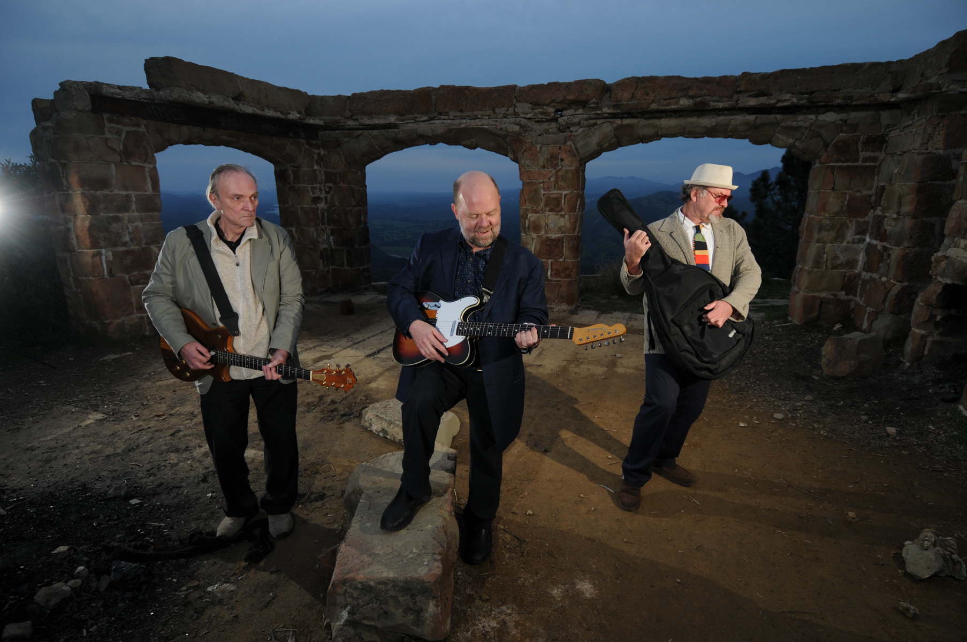
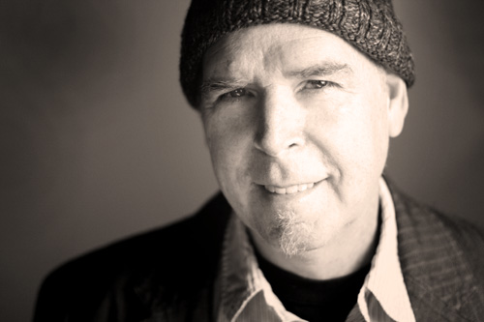

What: Headless Household, "Remembering Kenny," with guest singer-songwriters
When: Monday, March 21, 7:30 p.m.
Where: SOhO, 1221 State St. Santa Barbara CA
Cost: $10, benefit for Sarah House
Information: (805)-962-7776, www.sohosb.com
Who: Dick Dunlap, Tom Lackner, Joe Woodard, Julie Christensen, Tom Buckner, Jim Connolly, Sally Barr, Bill Flores, Tom Ball and ? Guest singers include Rebecca Troon, Natalie D-Napoloen, and more…
(photo: Paul Wellman)
Members of the eclectic group Headless Household were among the many shocked and saddened by the passing of the wonderful musician Kenny Edwards last September, from complications of cancer. There was a personal connection in that Edwards had recorded and performed with the band for seven years, always game to join in the band’s style-hopping antics and enriching the band’s music—especially the "Americana" chapter of the band's songbook.
In tribute to Edwards’ contribution to the band, and to the music of other artists in his adopted hometown of Santa Barbara, Headless Household is hosting a tribute night, Monday, March 21 at SOhO, starting at 7:30 p.m., with proceeds benefitting Sarah House. “Remembering Kenny” will feature a second set of Household music which involved Edwards, live and on record (he was involved in the albums post-Polka, Blur Joan and Basemento). An opening set will feature singers connected with Edwards’ work, as producer, guitarist, vocalist, mandolinist and all-around supportive, spiritually centered and deeply musical persona.
Edwards, who moved to Santa Barbara a decade ago and got enmeshed in its musical community (including with Headless Household) had finally begun recording as a solo artist in the last chapter of his life, releasing the wonderful albums Kenny Edwards (2002) and Resurrection Road (2009). This capped off a stellar resume including working with Linda Ronstadt, starting with her earliest public phase in the Stone Poneys, working as an important architect of the ‘70s country-rock sound in Los Angeles, and working as accompanist with longtime ally Karla Bonoff and Wendy Waldman.
More details on the SOhO tribute to come…

Links:
www.householdink.com/news.htm
www.myspace.com/headlesshousehold
www.householdink.com/headless.htm

for photos: www.householdink.com/hhphotos.htm

re: Kenny:

http://en.wikipedia.org/wiki/Kenny_Edwards

http://www.kennyedwards.com/

http://www.myspace.com/kennyedwards2

http://latimesblogs.latimes.com/music_blog/2010/08/linda-ronstadt-kenny-edwards.html

http://www.independent.com/news/2010/sep/13/kenny-edwards-1946-2010/

Press bites
“…solid musicianship and an admirable willingness to toss in whatever strikes their fancy.”
--Aaron Steinberg, Jazz Times
--“Music this wildly diverse can never be properly marketed in this age of specialization, but that doesn’t make it any less extraordinary.” --Bill Milkowski, Tower Pulse magazine
--“Headless Household still seems to think that a mind is a terrible thing to waste..” --Greg Burk, L.A. Weekly

--“Overall the vibe was great and the music eclectic enough to satisfy any head, household member or not.” --Charles Donelan, Santa Barbara Independent, re: the group’s Lobero Theatre concert in 2010

_____________________________________________________________________________________
e: info@householdink.com
w: www.householdink.com

