
p.o. box 2093, Santa Barbara, CA 93120
(805) 687-3963, FAX (805) 682-8305
e-mail: info@householdink.com (www.householdink.com)

Eclectic band Headless Household celebrates 25th anniversary (a year late) with new double album, Basemento, and their first concert at the Lobero Theatre, Friday, March 19

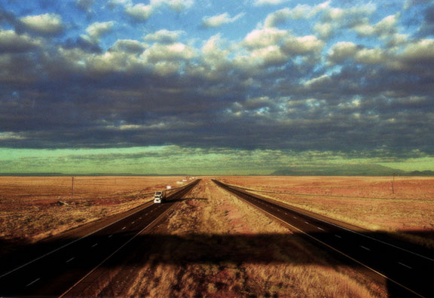
What: Headless Household, 25th anniversary concert (a year late)/CD release party for the double-disc Basemento
When: Friday, March 19, 2010, at 8 p.m.
Where: Lobero Theatre, E. Canon Perdido
Tickets: $15, general and $10, seniors and students. Box office: (805) 963-0408, or, web-wise, 963-0761, www.lobero.com
Who: Dick Dunlap, Tom Lackner, Chris Symer, Joe Woodard, Julie Christensen, Glen Phillips, Tom Buckner, Tom Ball, Bill Flores, and more…
(photo: Kim Reierson, from Eighteen)
Time plows forward, as does the urge to make music, for some. Both can be unstoppable forces. So here we have the 25th anniversary (a year late, thanks to the Tea Fire, and other factors) of Headless Household, Santa Barbara’s peculiar and ongoing, eclectic excuse of a band. Mixing up mixed-up elements of jazz, free improvisation, avant-Americana, Europeana, rock, soul and a new strain of Braziliana (in time for the bossa nova’s 50th birthday), the band presents its first concert in the historic Lobero Theatre, on Friday, March 19, coinciding with the CD release party for its eighth feature-length album, the double-disc item called Basemento.
As usual, a large and mobile band of players will appear, including the core quartet--Dick Dunlap (keyboards), Tom Lackner (percussives), Chris Symer (bass) and Joe Woodard (guitars). Other kindly “honorary householders” making the Lobero concert include vocalists Julie Christensen and Glen Phillips, saxist Tom Buckner, harmonica wizard Tom Ball, pedal steel player/multi-axman Bill Flores and others, tba. All those artists appeared on the recording, as did famed NYC-based alto saxist Dave Binney—a longtime friend of the Household—and Santa Barbara-turned-New Yorker Nate Birkey on trumpet and a vocal, as well as beloved mando-tarist-singer Kenny Edwards.
Basemento—the latest findings from the Household “basement”(actual and figurative)--is another hard-to-pinpoint musical journey, running through the jungles of genres, a torch song or two, sweet vocals and electro-acoustic ambient constructions. Etcetera. It seemed only proper to make it a two-disc album, one leaning more “inside” and the other “outside.”
In progress for five years, Basemento was interrupted for nearly a year after the Tea Fire threw the process off course. Drummer-engineer-producer Tom Lackner’s “Tompound” studio was in the heart of the Mountain Drive Tea Fire devastation, but miraculously survived (a Basemento session there ended one hour before the start of that fire, on November 13, 2008).
Previous albums to date, all on the in-house Household Ink Records label: Headless Household (1987), Inside/Outside USA (1993), ITEMS (1995), Free Associations (1999), mockhausen (2000), post-Polka (2003), and Blur Joan (2005). More to come, apparently.

What the press has been saying:

(re: Blur Joan)

“Soundwise, it is an eclectic and surprisingly alluring program that covers a variety of genres that, while certainly experimental, remains accessible. The group’s interest in the fusion of electric and acoustic touches is seen from the outset… Overall, a quirky--in a good way--outing from a group that is certainly charting its own course.” --Jay Collins, Cadence

“…solid musicianship and an admirable willingness to toss in whatever strikes their fancy.”
--Aaron Steinberg, Jazz Times

“Long-running Santa Barbara eclecto-jazz weirdoes Headless Household have simmered all their exotic flavors into a very palatable goulash called Blur Joan (Household Ink). Joe Woodard,Dick Dunlap and Tom Lackner really orchestrated this one, and with the help of brilliant friends (Dave Binney, Jim Connolly, Julie Christensen et al.), swing and waltz and reggae and sound effects unite — natural, warm and full of protein.” --Greg Burk, Los Angeles Weekly

(other notes…)

--“Music this wildly diverse can never be properly marketed in this age of specialization, but that doesn’t make it any less extraordinary.” --Bill Milkowski, Tower Pulse magazine

--“Headless Household achieved regional cult status by the late 1990s, thanks to their quirky and eclectic kind of new music, their relentless live shows and a string of albums….” --All-Music Guide (www.allmusic.com)

“The first thing to understand about the Household’s music is that when they announce a genre—say, polka for example—that hardly means they will stick to anything much resembling a traditional polka, or even that one of their polkas will sound much like another…. What unites these disparate approaches is a commitment to the sound and values of free improvisation… Everything that gets thrown into this musical blender seems to belong there…Here’s to many more years of this unique Santa Barbara tradition. ” --Charles Donelan, Santa Barbara Independent, re: the 2006 xmas concert

“This is a complex musical aggregation whose takes on various musical forms are fascinating. Each of the members is a solid professional -- a musician whose experience encompasses pop, jazz, classical, rock, and as-yet-undefined musical disciplines.” --Stanley Naftaly, Santa Barbara News-Press

--“Headless Household still seems to think that a mind is a terrible thing to waste..” --Greg Burk, L.A. Weekly
_____________________________________________________________________________________
Downloadable photos @ www.householdink.com/picturehole.htm
For further info, photos, mp3s, CDs, press clips, etcetera, please e-mail info@householdink.com or call (805) 687-3963. www.householdink.com

