
p.o. box 2093, Santa Barbara, CA 93120
e-mail: info@householdink.com (www.householdink.com)

Headless Household celebrates 20th (sorta) annual xmas concert at the Center Stage, Monday, December 3, 2012

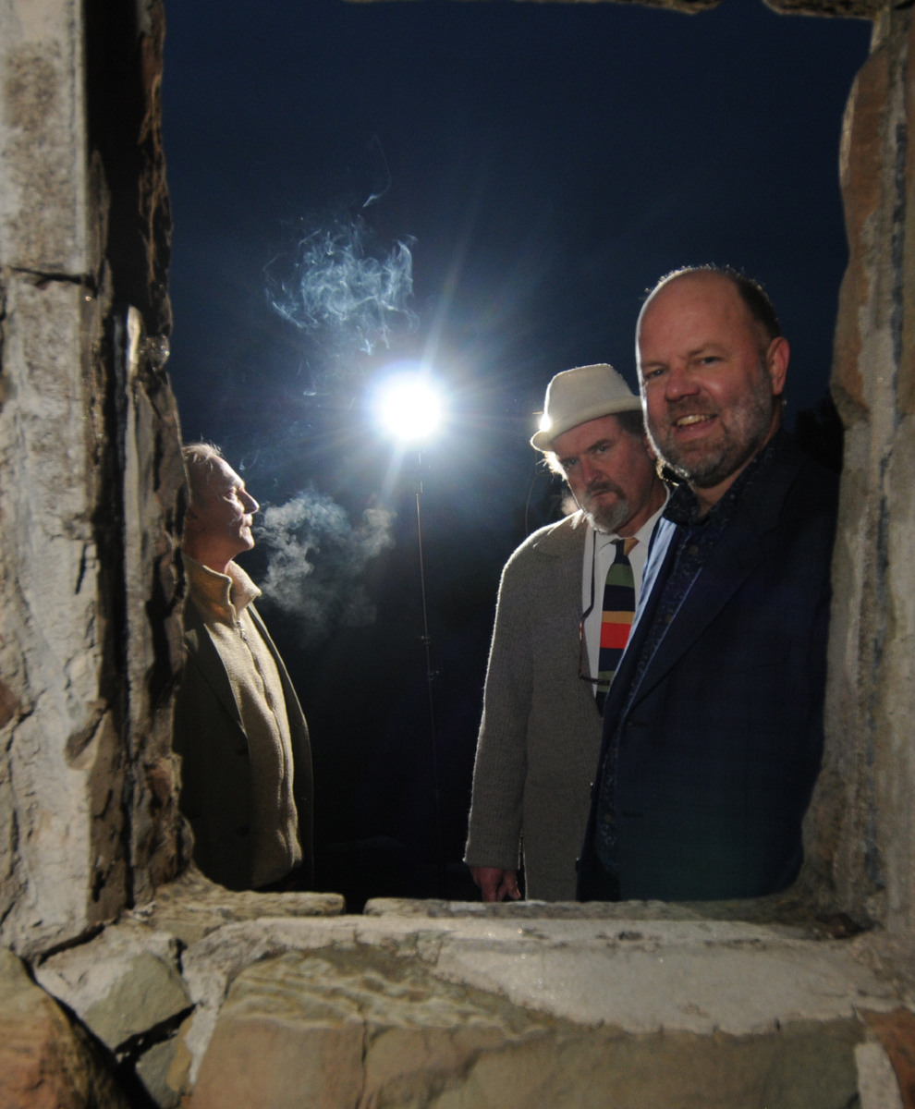
What: Headless Household, 20th (sorta) annual xmas concert at Center Stage
When: Monday, December 3, 2012, at 8 p.m.
Where: Center Stage Theater, upstairs in Santa Barbara’s Paseo Nuevo. Tickets are $15, general and $12, seniors and students. Box office: (805) 963-0408, or, web-wise, www.centerstagetheater.org.
Who: Dick Dunlap, Tom Lackner, Joe Woodard, Julie Christensen, Tom Buckner, Sally Barr, Bill Flores, Tom Ball… and ?
Still happily confused after all these years, in terms of what to call its music, the madly eclectric Headless Household continues on the merry path to… ? Meanwhile, numbers are noted along the way. This year’s notable number: the band will play its 20th (sorta) annual xmas period concert at Center Stage Theater, on Monday, December 3. The “sorta” referes to a three-year hiatus, triggered by the Tea Fire and aftermath.
Way back when, the band – formed in 1983 and starting its recording life in 1987 – was looking for a way to move out of the nightclub hurly burly and do a more theater-based show. Center Stage had recently opened its doors, and a artist-site match was made.
As usual, Headless Household’s core quartet, Dick Dunlap on keys, Tom Lackner on drums, Joe Woodard on guitar and songmaking (and bassist in absentia, Chris Symer, now a Seattle-ite) is amended by a critical addition of musical allies, including heroic saxist Tom Buckner, singer Julie Christensen, violinist Sally Barr, pedal steel et al man Bill Flores, and others tba.
Among other holidazed treats, old and new, the band will play songs from its work-in-progress, an all-ballads album, which will be its ninth release to date on the in-house Household Ink Records label. In 2010, the band released its (belated) 25th anniversary with the release of its schizoid two-disc album Basemento, with a special CD release concert at the Lobero Theatre.
Household Ink Records titles to date: Headless Household (1987), Inside/Outside USA (1993), ITEMS (1995), Free Associations (1999), mockhausen (2000), post-Polka (2003), Blur Joan (2005) and Basemento (2010). The beat (and intentional lack thereof) goes on.

Links:
www.householdink.com/news.htm

www.householdink.com/headless.htm

www.myspace.com/headlesshousehold

www.facebook.com/HeadlessHousehold

www.youtube.com/MrHeadlessHousehold

Press quips & clips:

(re: Basemento)

http://www.relix.com/reviews/cds/2010/07/22/gabor-szabo-headless-household-omar-souleyman-and-more-ear-crystals

Santa Barbara’s Headless Household celebrates 25 years of criminal neglect with a wonderful double album, Basemento (Household Ink). Come for “This, That…,” guitarist Joe Woodard’s song-oriented SoCal strip-mall blend of jazzy bossa nova and Bakersfield country laments (i.e., “Jobim Meets Jim Beam”). But stay for “…The Other,” a disk’s worth of some of the smartest and friendliest psychedelic jazz you’ll ever snuggle up to. Guest saxophonist Dave Binney applies the hot sauce liberally to these nine smart, incisive sonic meditations encompassing everything from British progressives like Henry Cow, gnarly New York downtown jazz, Weather Report’s international feel and the heady cosmic geologies of countless Grateful Dead space excursions. --Richard Gehr, Relix, July, 2010

(re: Blur Joan)

“Soundwise, it is an eclectic and surprisingly alluring program that covers a variety of genres that, while certainly experimental, remains accessible. The group’s interest in the fusion of electric and acoustic touches is seen from the outset… Overall, a quirky--in a good way--outing from a group that is certainly charting its own course.” --Jay Collins, Cadence

“…solid musicianship and an admirable willingness to toss in whatever strikes their fancy.”
--Aaron Steinberg, Jazz Times

“Long-running Santa Barbara eclecto-jazz weirdoes Headless Household have simmered all their exotic flavors into a very palatable goulash called Blur Joan (Household Ink). Joe Woodard,Dick Dunlap and Tom Lackner really orchestrated this one, and with the help of brilliant friends (Dave Binney, Jim Connolly, Julie Christensen et al.), swing and waltz and reggae and sound effects unite — natural, warm and full of protein.” --Greg Burk, Los Angeles Weekly

Re: Basemento CD release concert at the Lobero Theatre, March 23, 2010:

“The audience for Friday night’s show was a great cross-section of the Santa Barbara art and music scene, and their reward for waiting a whole extra year for Headless Household’s 25th anniversary concert was the group’s best live performance in recent memory. Drawing primarily on material from their brand new double CD release, Basemento, the Household played 21 numbers over the course of two long sets, and earned a stormy standing ovation at the end of the night.
“Overall the vibe was great and the music eclectic enough to satisfy any head, household member or not.” –Charles Donelan, Santa Barbara Independent

“Let’s hope that Headless Household continues to celebrate its 25th anniversary like this for at least a few more years.” –Jeff Moehlis, Noozhawk

“This is a complex musical aggregation whose takes on various musical forms are fascinating. Each of the members is a solid professional -- a musician whose experience encompasses pop, jazz, classical, rock, and as-yet-undefined musical disciplines.” --Stanley Naftaly, Santa Barbara News-Press
--“Music this wildly diverse can never be properly marketed in this age of specialization, but that doesn’t make it any less extraordinary.” --Bill Milkowski, Tower Pulse magazine

--“Headless Household achieved regional cult status by the late 1990s, thanks to their quirky and eclectic kind of new music, their relentless live shows and a string of albums….” --All-Music Guide (www.allmusic.com)

--“Headless Household still seems to think that a mind is a terrible thing to waste..”
--Greg Burk, L.A. Weekly

Downloadable photos @ www.householdink.com/picturehole.htm
For further info, photos, mp3s, CDs, press clips, etcetera, please e-mail info@householdink.com www.householdink.com
Headless Household photos: http://www.householdink.com/hhphotos.htm

