
p.o. box 2093, Santa Barbara, CA 93120
e-mail: info@householdink.com (www.householdink.com)

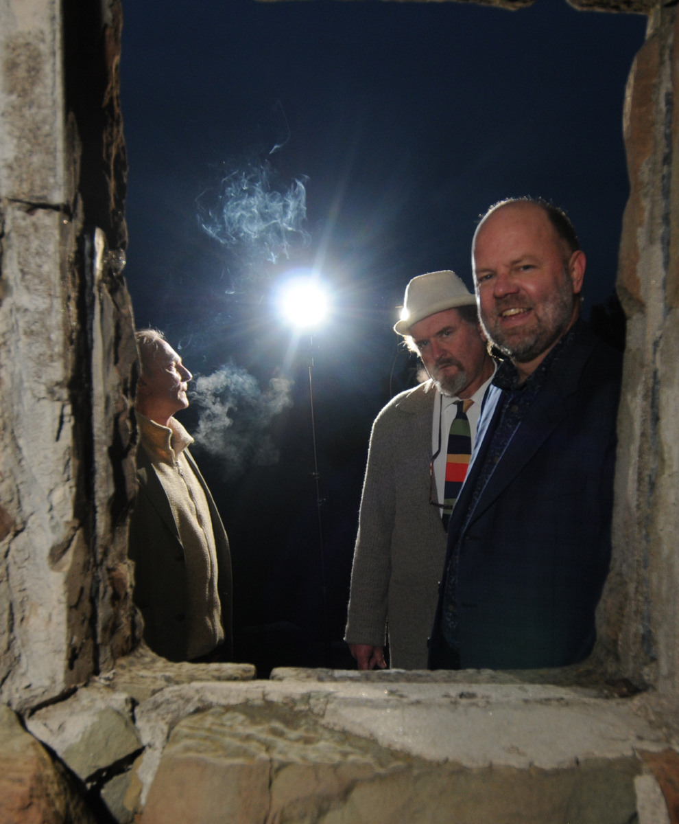
Genre-mashing band Headless Household celebrates 19th (sorta) annual xmas concert at the Center Stage,
Monday, November 28, 2011

What: Headless Household, 19th (sorta) annual xmas concert at Center Stage
When: Monday, November 28, 2011, at 8 p.m.
Where: Center Stage Theater, upstairs in Santa Barbara’s Paseo Nuevo. Tickets are $15, general and $10, seniors and students. Box office: (805) 963-0408, or, web-wise, www.centerstagetheater.org.
Who: Dick Dunlap, Tom Lackner, Joe Woodard, Julie Christensen, Tom Buckner, David Piltch, Sally Barr, Bill Flores, Tom Ball… and ?
After playing its xmas concerts at Center Stage Theater for 18 years in a row, the hopelessly eclectic band Headless Household found its groove interrupted by the Tea Fire in 2008, and is finally getting back in gear/the groove with its 19th (sorta) annual xmas concert this year. In 2010, the band released its (belated) 25th anniversary with the release of its schizoid two-disc album Basemento, with a special CD release concert at the Lobero Theatre.
On that album, as throughout its oddball history and over now eight albums, the band shamelessly and restlessly mixes up elements of jazz, free improvisation, avant-Americana, European-a, prog rock, funk, Braziliana and more.
As usual, a large and mobile band of players will appear—as-yet all confirmed. But the concert will certainly feature founding Dick Dunlap (keyboards), Tom Lackner (percussives), and Joe Woodard (guitars), vocalist Julie Christensen, saxist Tom Buckner, violinist/vocalist Sally Barr, pedal steel player/multi-axman Bill Flores, bassist David Piltch, harmonica hero Tom Ball, and others tba.
Previous albums to date, all on the in-house Household Ink Records label: Headless Household (1987), Inside/Outside USA (1993), ITEMS (1995), Free Associations (1999), mockhausen (2000), post-Polka (2003), and Blur Joan (2005). More to come, apparently.

Links:
www.householdink.com/news.htm
www.householdink.com/headless.htm
www.myspace.com/headlesshousehold
www.facebook.com/HeadlessHousehold
www.youtube.com/MrHeadlessHousehold

Press quips & clips:

(re: Basemento)

http://www.relix.com/reviews/cds/2010/07/22/gabor-szabo-headless-household-omar-souleyman-and-more-ear-crystals

Santa Barbara’s Headless Household celebrates 25 years of criminal neglect with a wonderful double album, Basemento (Household Ink). Come for “This, That…,” guitarist Joe Woodard’s song-oriented SoCal strip-mall blend of jazzy bossa nova and Bakersfield country laments (i.e., “Jobim Meets Jim Beam”). But stay for “…The Other,” a disk’s worth of some of the smartest and friendliest psychedelic jazz you’ll ever snuggle up to. Guest saxophonist Dave Binney applies the hot sauce liberally to these nine smart, incisive sonic meditations encompassing everything from British progressives like Henry Cow, gnarly New York downtown jazz, Weather Report’s international feel and the heady cosmic geologies of countless Grateful Dead space excursions. --Richard Gehr, Relix, July, 2010

(re: Blur Joan)

“Soundwise, it is an eclectic and surprisingly alluring program that covers a variety of genres that, while certainly experimental, remains accessible. The group’s interest in the fusion of electric and acoustic touches is seen from the outset… Overall, a quirky--in a good way--outing from a group that is certainly charting its own course.” --Jay Collins, Cadence

“…solid musicianship and an admirable willingness to toss in whatever strikes their fancy.”
--Aaron Steinberg, Jazz Times

“Long-running Santa Barbara eclecto-jazz weirdoes Headless Household have simmered all their exotic flavors into a very palatable goulash called Blur Joan (Household Ink). Joe Woodard,Dick Dunlap and Tom Lackner really orchestrated this one, and with the help of brilliant friends (Dave Binney, Jim Connolly, Julie Christensen et al.), swing and waltz and reggae and sound effects unite — natural, warm and full of protein.” --Greg Burk, Los Angeles Weekly

Re: Basemento CD release concert at the Lobero Theatre, March 23, 2010:

“The audience for Friday night’s show was a great cross-section of the Santa Barbara art and music scene, and their reward for waiting a whole extra year for Headless Household’s 25th anniversary concert was the group’s best live performance in recent memory. Drawing primarily on material from their brand new double CD release, Basemento, the Household played 21 numbers over the course of two long sets, and earned a stormy standing ovation at the end of the night.
“Overall the vibe was great and the music eclectic enough to satisfy any head, household member or not.” –Charles Donelan, Santa Barbara Independent

“Let’s hope that Headless Household continues to celebrate its 25th anniversary like this for at least a few more years.” –Jeff Moehlis, Noozhawk

“This is a complex musical aggregation whose takes on various musical forms are fascinating. Each of the members is a solid professional -- a musician whose experience encompasses pop, jazz, classical, rock, and as-yet-undefined musical disciplines.” --Stanley Naftaly, Santa Barbara News-Press
--“Music this wildly diverse can never be properly marketed in this age of specialization, but that doesn’t make it any less extraordinary.” --Bill Milkowski, Tower Pulse magazine

--“Headless Household achieved regional cult status by the late 1990s, thanks to their quirky and eclectic kind of new music, their relentless live shows and a string of albums….” --All-Music Guide (www.allmusic.com)

--“Headless Household still seems to think that a mind is a terrible thing to waste..”
--Greg Burk, L.A. Weekly

Downloadable photos @ www.householdink.com/picturehole.htm
For further info, photos, mp3s, CDs, press clips, etcetera, please e-mail info@householdink.com www.householdink.com
Headless Household photos: http://www.householdink.com/hhphotos.htm

