
P.O. Box 2093, Santa Barbara, CA 93120
(805) 687-3963, FAX (805) 682-8305
e-mail: info@householdink.com (www.householdink.com)

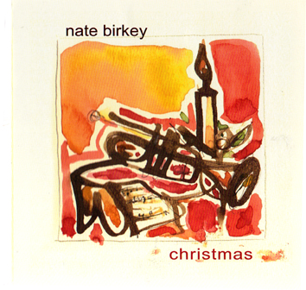
nate birkey
christmas

Following up on his well-received album almost home, released in the summer of 2008, lyrical and evocative trumpeter-vocalist Nate Birkey comes out swinging in holiday album mode. Joined by the same impressive NYC-based band as on the earlier title, Birkey brings both freshness and traditional warmth to seasonal songs on his simply, aptly-entitled christmas.
As with his other albums over the last decade-plus, christmas finds Birkey approaching this timeless and timely body of music with focused emotionality and understatement. Tunes like “O Tannenbaum,” the great Vince Guaraldi classic “Christmas Time is Here,” “I’ll be Home for Christmas” and the closing “I Heard the Bells on Christmas Day” emerge in treatments both comforting and refreshing on the ear. Just off the beaten yuletide path are Frank Loesser’s “What are you Doing New Year’s Eve” and the Sammy Cahn/Jules Styne song “The Christmas Waltz,” and “Hanukkah, Oh Hannukkah” broadens the seasonal scope of the set.
On the album, Birkey’s sixth to date, are pianists Jim Ridl and Steve Rudolph, bassist Tony Marino, drummer Marko Marcinko, and guitarist Vic Juris. On occasion, Birkey mixes flugelhorn—somehow, a wise Christmas-spirited sound--into his trumpeter/vocalist mix.
For nearly twenty years, the Colorado native was based in Santa Barbara, California, where he had studied at UC Santa Barbara after attending Berklee School of Music in Boston. But an eastward move to New York in 2005 has broadened Birkey’s horizons and deepened both his artistic resolve and his musical evolution.
Christmas is more than a stocking stuffer, but a substantial piece of music-making, on beloved material which Birkey seems a natural to make musical again.

PRESS CLIPPINGS:

"Make way for Nate Birkey, a talented trumpeter / vocalist / composer who has been honing his talents in the Santa Barbara Jazz scene and is now getting the national exposure he deserves. Birkey's latest release, Shortest Day, recorded live in 2004, showcases his considerable gifts and puts him front and center among Jazz' most promising musicians." --Florence Wetzel, All About Jazz - New York

"Nate Birkey, he of mysterious charisma, subtle gossamer trumpet lines and understated voice, hunches over the microphone and leans into his phrases, shutting out the world." --Josef Woodard, Los Angeles Times

“All you have to do is look at his two current CDs, The Mennonite and the vocal driven Ballads, to see his affinity for Chet Baker. On both, the trumpeter strikes a pose musically and physically that is very Chet like. But the sounds are solid, and Birkey definitely deserves a place on the impressive list of trumpeters with a Denver connection.” –Norman Provizer, Rocky Mountain News

On the www:
www.natebirkey.com
www.householdink.com/birkey.htm
www.myspace.com/natebirkey
________________________________________________________________________________________________________
Press clips and playlists are greatly appreciated.
For info, photos, mp3s, and miscellany, please visit our humble web-home: www.householdink.com.

