
p.o. box 2093, Santa Barbara, CA 93120
e-mail: info@householdink.com (www.householdink.com)
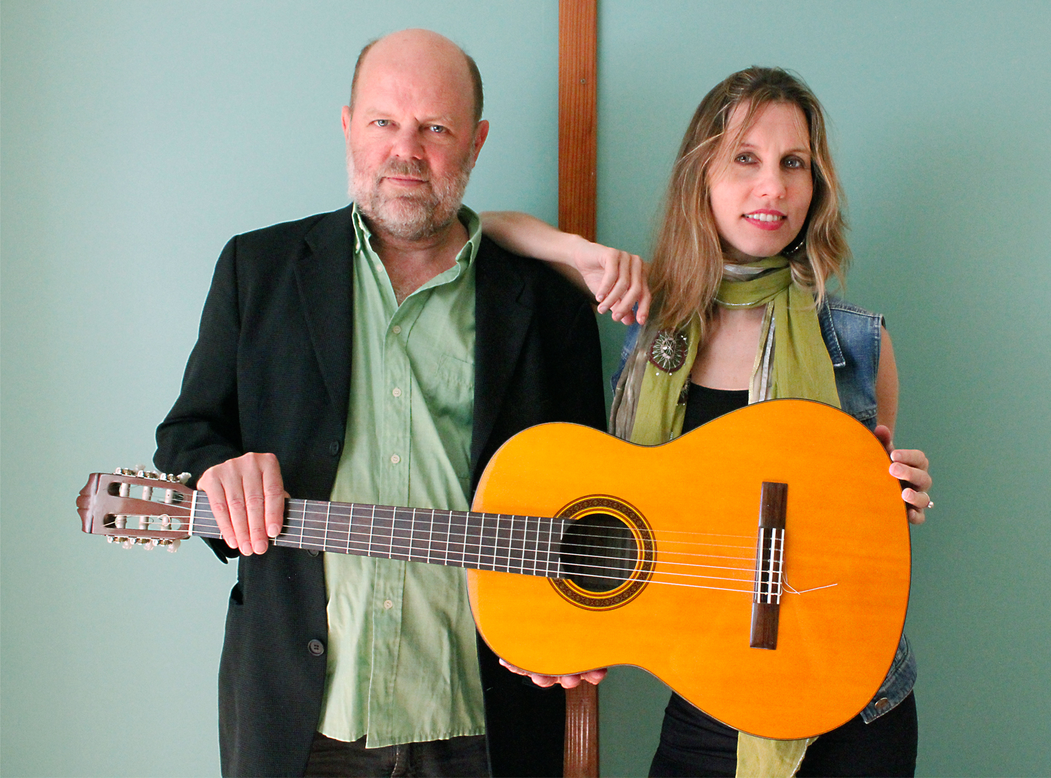
Lucinda Lane goes SOhO
with Spencer & Todd’s Swingin’ Moods
Wednesday, July 16

What: Lucinda Lane, new-ish original “IndieBossaSwingTwang” band
Who: Nicole Lvoff, voice; Joe Woodard, guitarist, songs; Tom Lackner, drums; Jim Connolly, bass, banjo; Bill Flores, pedal steel, and etceteras.
With: Spencer & Todd’s Swingin’ Moods, featuring Spencer Barnitz and Todd Capps “
Where: SOhO Restaurant and Music Club 1221 State Street, Upstairs in Victoria Court.
805 962-7776 www.sohosb.com
When: 8:30 p.m., Wednesday, July 16: Spencer & Todd at 7:30, Lucinda Lane at 8:30
$: 8 bux in advance, $10 at the door
www.lucindalanemusic.com

