
p.o. box 2093, Santa Barbara, CA 93120
e-mail: info@householdink.com (www.householdink.com)

HI@25

a “microfest,” celebrating 25 years of Household Ink Records, SOhO, May 21

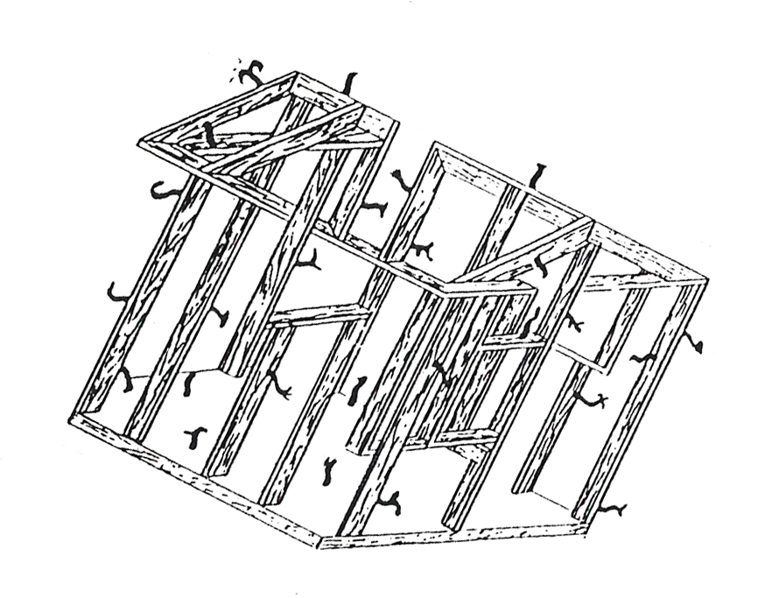
For immediate release:
May 4, 2013

What: “HI@25,” a “microfest” with multiple acts on the Household Ink Records label
When: Tuesday, May 21, 7 p.m.
Where: SOhO, 1221 State St., Santa Barbara
Cost: $10
Info: (805) 962-7776, www.sohosb.com
Who: Headless Household, Natalie D-Napoleon, Julie Christensen, Lucinda Lane, Zen Horse Repair, and…?

Article on Household Ink Records, Down Beat magazine, September, 2012
http://www.householdink.com/db_hi_2012.htm
Santa Barbara-based label Household Ink Records was born, out of necessity and curiosity, in 1987, as an outlet and “in-house” label for the eclectic band Headless Household. By the early ‘90s, the roster and the sense of a future had grown, including acts such as flapping, Flapping, Dudley, Lean-To, Fringe Deities, Nate Birkey and more.

Cut to 2013, and the genre-diverse label is 25 years deep and with a catalogue of 36 titles (with eight by Headless Household) and counting. It’s a ripe time for another “microfest,” of the kind the label had five years ago at SOhO.

Welcome to “HI@25.” On Tuesday, May 21 at SOhO, for three hours-and-change, a handful of acts on the roster will kick up sonic dust, including the still description-defying Headless Household, respected “Americana” artists Julie Christensen and Natalie D-Napoleon (the label family’s newest addition), the wily coyote-esque Zen Horse Repair, and Lucinda Lane, a brand new band, presently hatching and going public.

This is a special gig for Headless Household in that Julie Christensen, its longstanding, outstanding and beloved vocalist, is moving on over to Nashville this summer, bringing a dozen-year Headless chapter to, not a close, but a quasi-hiatus. We hope. Also joining the Household same-olds – Dick Dunlap, Tom Lackner and Joe Woodard – at SOhO are Tom Buckner, Bill Flores, Sally Barr, Tom Ball, and possible surprised guests.
Headless Household has a discography of eight titles to date: Headless Household (1987), Inside/Outside USA (1993), ITEMS (1995), Free Associations (1999), mockhausen (2000), post-Polka (2003), Blur Joan (2005) and Basemento (2010). They are currently in kickstarter mode, with a campaign to raise greenbacks for their ninth album, and all-ballads affair (linkage here).

www.householdink.com/headless.htm

Iowa-born and variously based in Austin, Texas, Los Angeles, Ojai – and, soon, Nashville –Christensen, a startlingly versatile singer, has a resume including work with Leonard Cohen, Van Dyke Parks, the pioneering country punk band the Divine Horseman and other projects. She also has a rich discography in her solo mode, including so –far three titles for Household Ink: the jazz-infused Something Pretty, and Where the Fireworks Are and the latest, her well-received Weeds like Us, the latter two in her more country-rock-folk-soul duds on – aptly described as “great prairie soul.” Christensen is moving upward and outward on her own terms.

www.stonecupid.com

Australian singer-songwriter Natalie D-Napoleon, now a Santa Barbaran, joined the Household Ink family last year, with the American release of her moving album Leaving Me Dry, produced by David Piltch (who also has a record out on Household Ink, Minister of the Interior), with the musical help of the late Kenny Edwars and Victoria Williams. Reviewing the album in No Depression, Karl Benon wrote that “when Australian singer-songwriter Natalie D-Napoleon wanted to turn her Americana-infused tones into a debut solo album, she seemingly opened up a map of the United States and firmly stuck a pin in the midst of the California's central coast. And it turned out to be a stroke of musical genius.”

www.natalied-napoleon.com

Zen Horse Repair, aka ZHR, aka the brain trust of singer-composer-Buddhist banjoist-poet Neal Crosbie and drummer/conspirator Tom Lackner, blissfully occupies a niche of its own on the label. Rootsy sounds, alien sounds, experimental backwoods treks, wry poetic wranglings and oddly catchy songs are part of the project’s unique mix, as heard on the HI album Ghost Brain.

www.householdink.com/zhr.htm

From the on-the-horizon perspective of the Household Ink roster, the band currently known as Lucinda Lane is a new project, with singer Nicole Lvoff and guitarist/songwriter Joe Woodard cooking up some new stew, something along the lines of IndieBossaJazzTwang. A debut album is currently in the works, in creative cahoots with drummer/ studio master Tom Lackner, and musical helpers tba.

Voila, HI@25... a Household party waiting to happen.

Downloadable photos @ www.householdink.com/picturehole.htm
For further info, photos, mp3s, CDs, press clips, etcetera, please e-mail info@householdink.com www.householdink.com
Headless Household photos: http://www.householdink.com/hhphotos.htm

