
P.O. Box 2093, Santa Barbara, CA 93120
(805) 687-3963, FAX (805) 682-8305
e-mail: info@householdink.com (www.householdink.com)

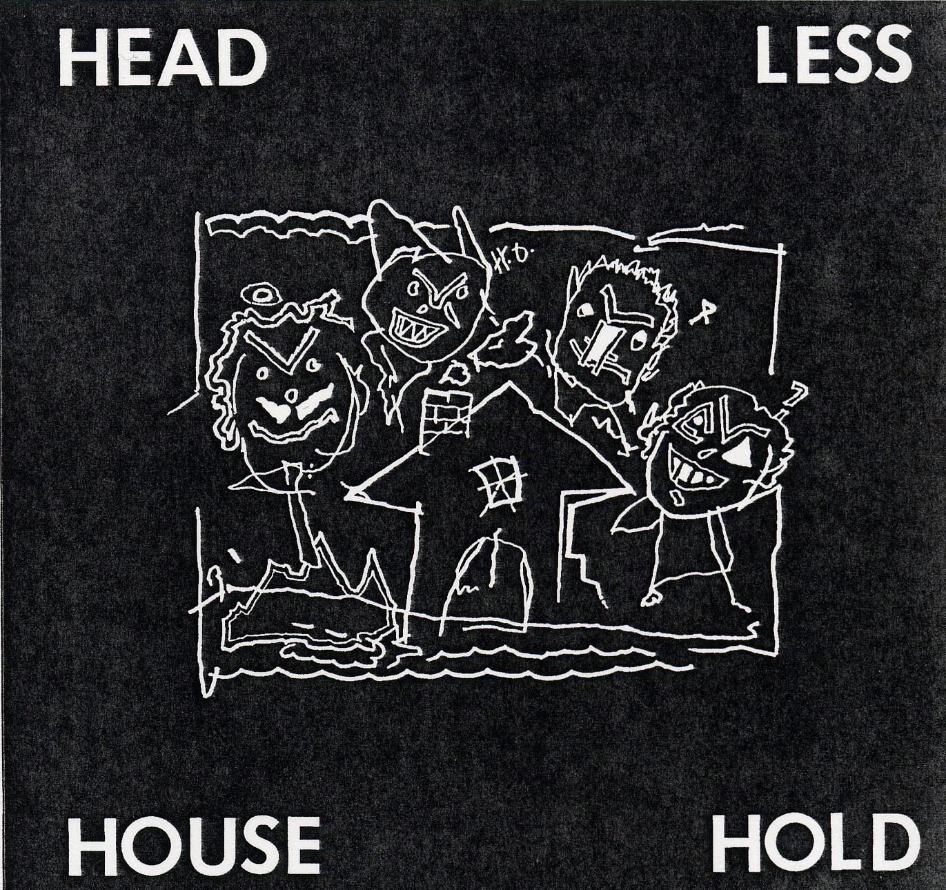
Headless Household
Headless Household
(1987, vinyl/compact disc)

Headless Household, the new music party combo, recorded its debut at Planet Studios in 1987, with the engineer-producer known as Bill 7 twisting knobs (yes, knobs) at Planet Studio. It was four years after the group formed, and release #1 for the Household Ink Records label. True to eclectic form, the tracks shift from free improv (“Year of the Donkey”) to scruffy sort-of-fusion (“One Form of Therapy,” “Rhythm Truck”) quasi-prog-rock (“Off the Beat”) to weird/warm gospel (“Gabriel”) to polka ("Isle of Hugh") and back. The band: Dick Dunlap, keys, Tom Lackner, perucssives, Chris Symer, bass, Chapman stick, Joe Woodard, guitars, banjo. Guests: Kathy Kelly on vocals, John Rapson on trombone, and Joseppi Scozzaro on accordion.

"Strange, cool rumblings from Southern California" --Jas Obrecht, Guitar Player.

"Following a private madness, they assemble (musical) nuggets into something great and, sometimes, even important. Using old and new instrumentation and technologies, Headless Household weave through tight turns and time-signatures" --B.H. Hart, Sound Choice.

"It's hard to categorize these guys, though their music's playful, quirky, sometimes downright silly, sometimes quite soothing" --New Music Distribution Service Catalogue blurb.

Downloadable photos @ www.householdink.com/picturehole.htm
For further info, photos, CDs, press clips, etcetera, please e-mail info@householdink.com
www.householdink.com

